
第40届国际龙家具展览会
暨第40届国际龙家具材料展览会
THE 40th INTERNATIONAL DRAGON FURNITURE FAIR

Feedback Form of Floor Plan of Standard Booth
标准展位布置图回执表

The following are the cutline explanation for standard booth. Exhibitors should remark the fixing and removing of side board and the location of lamp on the booth map correctly.（Please remark if the side board is not needed for raw space）

Cutline：
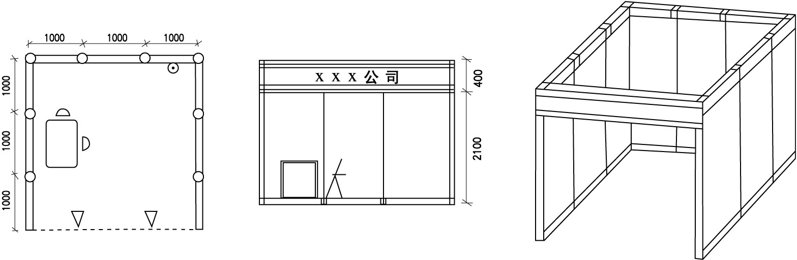

A、 Side board
B、------- Side board removed
C、△ location of light
D、⊙ location of electrical outlet

Company Name：
Booth No.：
Contact person： （Mr./Ms.）Mobile Phone：
Tel.： Fax：

Company (Seal & Signature)：

Query telephone: 86-757-23888888, Fax: 86-757-23888799

